**Practical Activity 4**

This bash script code validates the strength of a given password

! /bin/bash

read -p "please enter password:" pass

count=`echo ${#pass}`

if [[ $count -gt 8 ]];then

echo "strong password secure user"

exit 1;

fi

echo $pass | grep "[A-Z]" | grep "[a-z]" | grep "[0-9]"

if [[ $? -ne 0 ]];then

echo "weak password"

exit 2;

fi

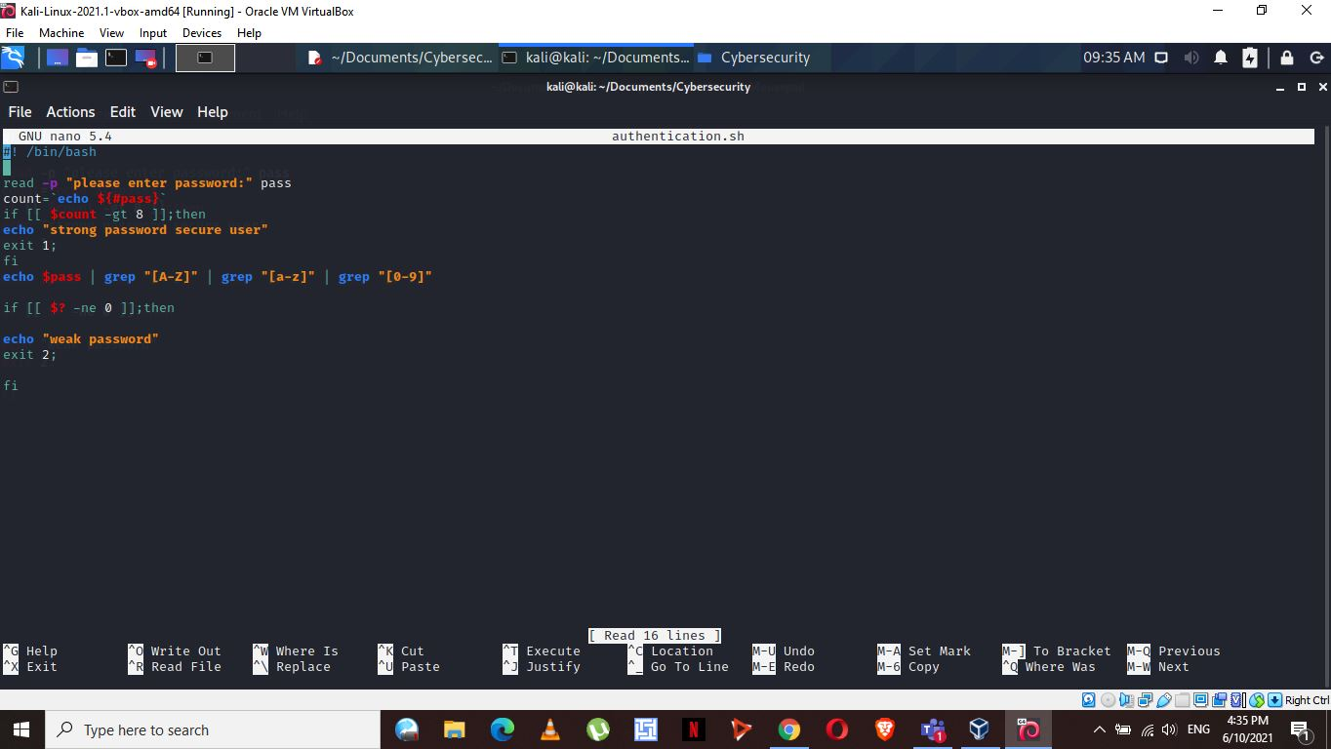

The script only accept a password with both small and capital letters, numbers and a length greater than 8. If a password does not meet the specified condition, it terms it as a weak password.

